Use Tableau with Apache Kylin
Date: August 2016
Update: Nov 2016
Author: Ramón Portolés, Alberto Linkedin

Intro
We can use Quick Start with Sample Cube of Kylin Project to make an example of integration with Tableau Software

Pre-requisites
First, you need Build Kylin Cube: Quick Start with Sample Cube: With firth step of link, you can check the result cube executing:
select part_dt, sum(price) as total_selled, count(distinct seller_id) as sellers from kylin_sales group by part_dt order by part_dt
Query results:
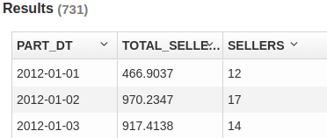
Second, Install Tableau Desktop 9.3.3 On windows

Used Software
- Kylin: 1.5.2
- Kylin ODBC 1.5 (Don’t use v1.3, don’t work)
- Tableau Desktop 9.3.3
(Update Nov 2016) Tested with Kylin 1.6.0 and Tableau Desktop 10.1.1 and work without problems. If you use the twb files from my GitHub, you will be prompted for convert to a new version (and you will not open this file with previous versions)

Create Connection
- Install Kylin ODBC
- Add DNS System in Windows
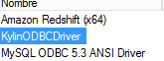
- And configure: User-name /Password: ADMIN / KYLIN
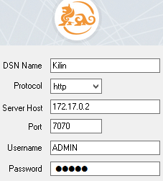
- Click Connect and Choose the project
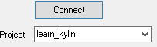
- Click on “Done”
- Download and install Tableu Desktop and launch it
- > >
- >
- Complete details connections (ADMIN /KYLIN), click done, click OK:
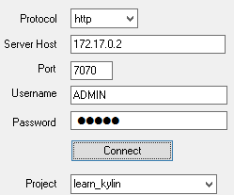
- Click on > > (In magnifying glass)
The result must be three new tables (on left panel):
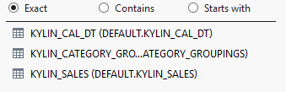
NOTE: Sometimes it doesn’t work correctly, Solution: close and open Tableau :)
- Add this tables to Tableau: Drag and Drop to 
- First “Kylin_sales” (Fact Table) and second “Kylin_Cal_DT” (Dimension table)
And Join Relation:
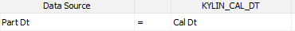
- Now do the same with “Kylin_Category_Groupings”
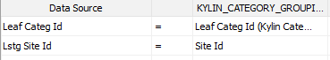
- The result must be:
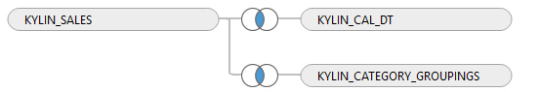
- Now if you click: 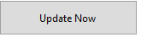, you must see this data table:
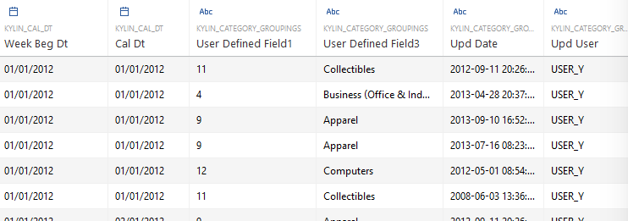

Intro to Sheet Elements
Go to Sheet 1:
You must see the Dimensions in left panel
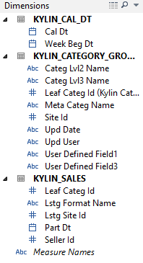

And measures:
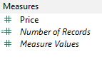

Our First WorkSheet
Drag and Drop “Cal_Dt” and “Price” like in picture:
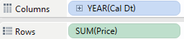

You can expand to Quarter and Months: Click on “Plus” of year:
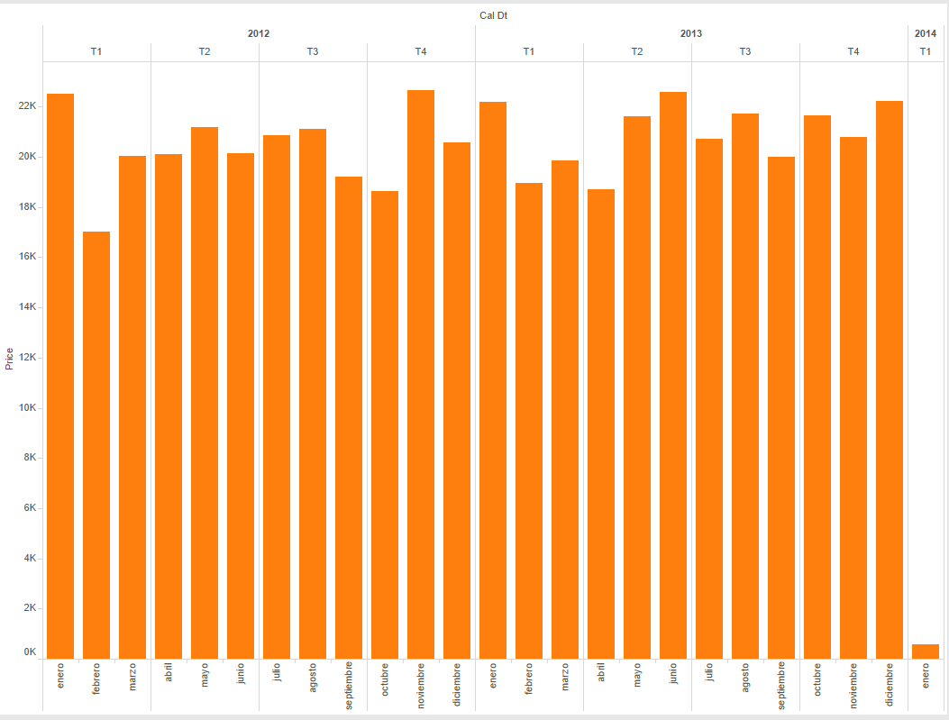

We can add sub-totals by category: Drag and Drop “Meta Categ Name” to “Color”
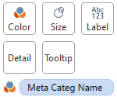
The result must be similar to:
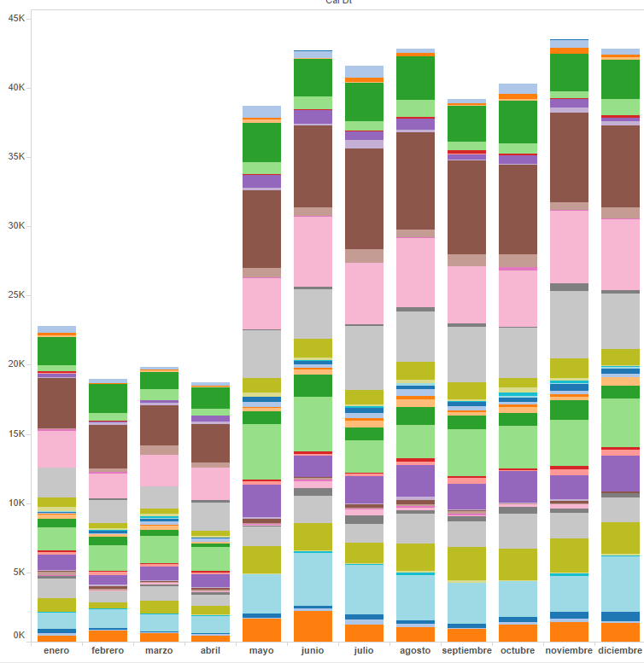

Second Worksheet
Create new Worksheet
Drag and Drop, and configure if us follows:
Then we can see the relations between “Meta Categ Name”, "L2" and "L3":
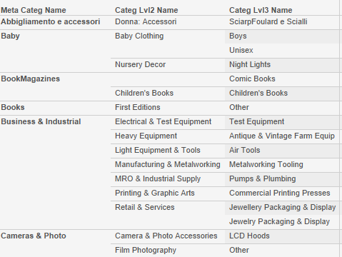
Delete the three fields in “Rows” and generate a hierarchy using Dimensions Menu (on the Left) Drag and Drop “Lvl2” over “Meta Categ Name” and after D & Drop “Lvl3”, the new result must be:
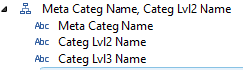
Drag and Drop the New hierarchy on “Rows” and expands it
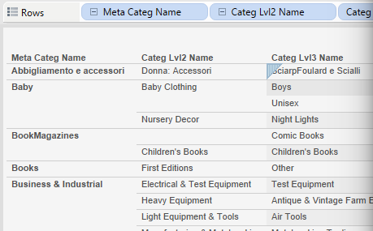
Change the diagram type to table: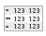

Drag and Drop “Price” to Rows, and watch the total price on th right hand side of table:
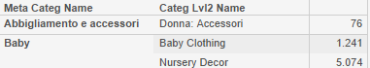
Now you can change the graph type:
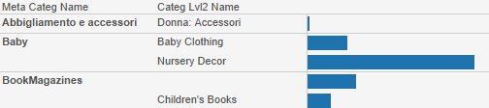

Create Dashboard
Create New Dashboard
Drag and Drop WorkSheet_1 and WorkSheet_2 to the new dashboard
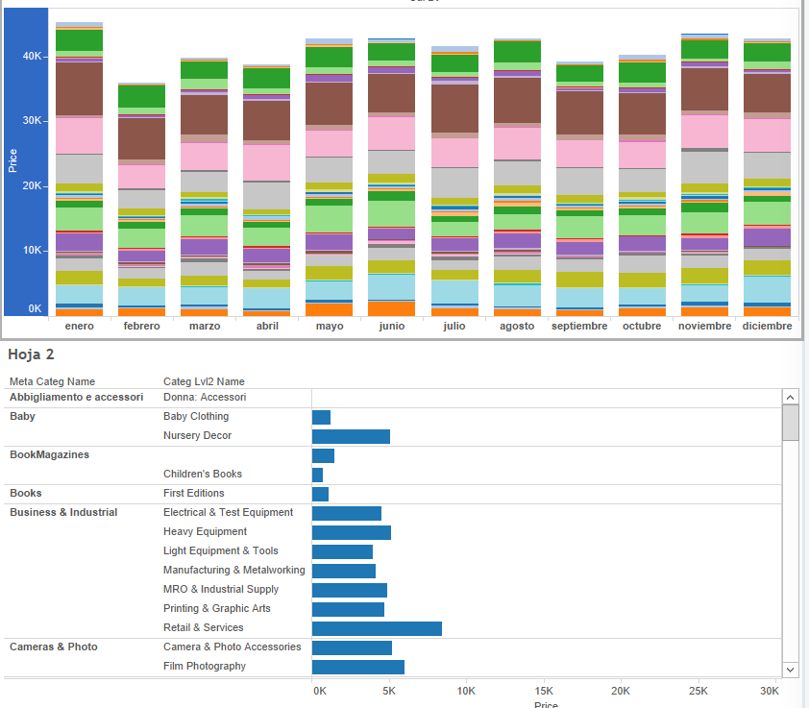

Add filter to dashboard
1º Add Filter to Worksheet_1 : 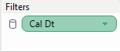
2º Configure the filter with using “All Using this Data Source”
3º Then check the Worksheet_2 and we will see that a new filter has been apppend: 
4º Add the filter to the dashboard: Select a Worksheet on the Dashboard, and right- click on upper edge
Filter > “Cal Dt”
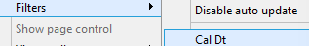

After that a new panel will appear on the right: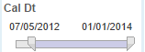, this filter will affect all the Dashboard’s Worksheets
Furthermore , you can filter by date clicking on month, in the upper worksheet 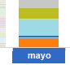
Or, you can filter by category, clicking in category : 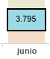

Final Result:
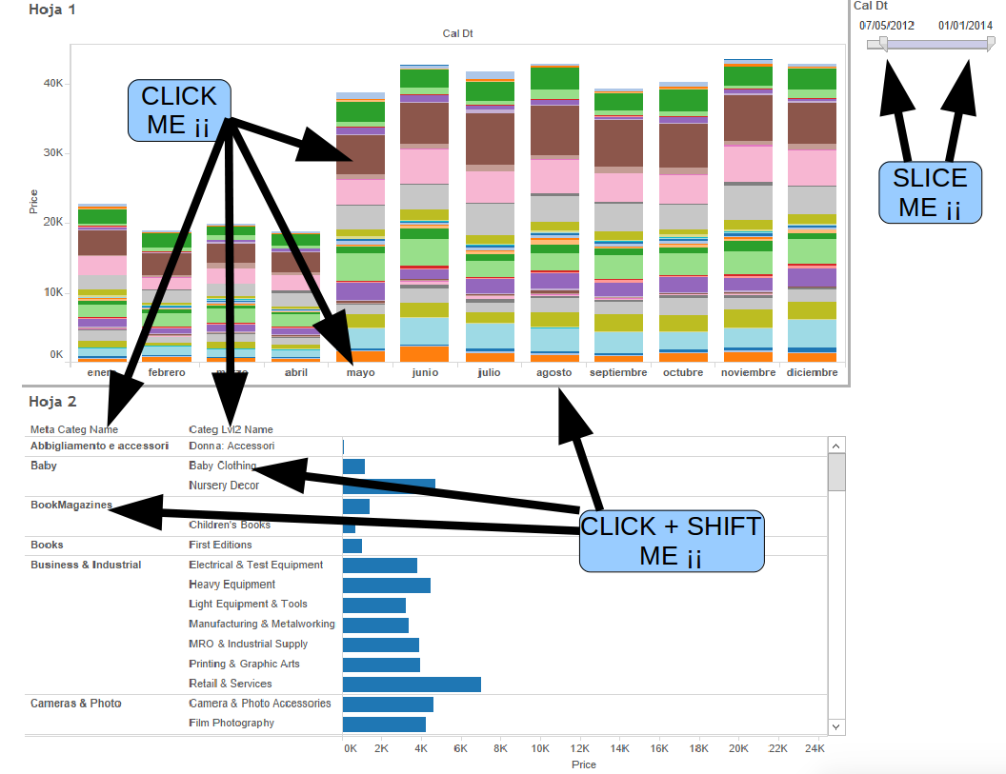
Tableau Files: Full.twb OnlyConnection.twb

For any suggestions, feel free to contact me
Thanks, Alberto

